Molecular weight of macromolecules:
“Molecular weight of a polymer is defined as sum of the atomic weight of each of the atoms in the molecules, which is present in the polymer”. ... Molecular Weight The Number Average Molecular Weight ( ) is the total weight of the polymer molecules divided by the total number of polymer molecules.
There are two types of molecular weights for macromolecules.
- The number-average molecular weight (M_{n})
- The weight-average molecular weight (M_{w})
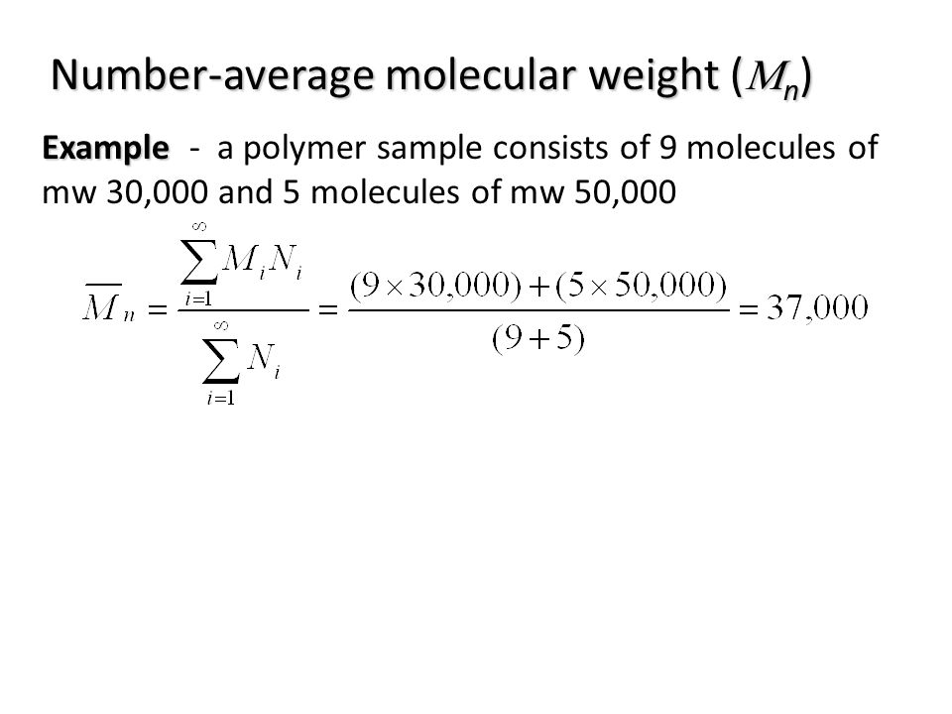
To Find: (a) The number-average molecular weight (b) The weight-average molecular weight (c) The degree of polymerization for the given polypropylene material

Molecular Weight Range (g/mol) xi wi
8,000–16,000 0.05 0.02
16,000–24,000 0.16 0.10
24,000–32,000 0.24 0.20
32,000–40,000 0.28 0.30
40,000–48,000 0.20 0.27
48,000–56,000 0.07 0.11

Number-average molecular weight:

Molecular wt. Range Mean Mi xi xiMi
8,000-16,000 12,000 0.05 600
16,000-24,000 20,000 0.16 3200
24,000-32,000 28,000 0.24 6720
32,000-40,000 36,000 0.28 10,080
40,000-48,000 44,000 0.20 8800
48,000-56,000 52,000 0.07 3640

Mn= ∑ xiMi = 33,040 g/mol

Weight-average molecular weight:

Molecular wt. Range Mean Mi wi wiMi
8,000-16,000 12,000 0.02 240
16,000-24,000 20,000 0.10 2000
24,000-32,000 28,000 0.20 5600
32,000-40,000 36,000 0.30 10,800
40,000-48,000 44,000 0.27 11,880
48,000-56,000 52,000 0.11 5720

M w =∑wiMi = 36,240 g/mol

The polymerization process, whether proceeding by chain growth or by step-growth, is ruled by random events. The result is a mixture of polymers that vary in chain length. A polymeric material, therefore, cannot be characterized by a single molecular weight like an ordinary substance. Instead, a statistical average calculated from the molecular weight distribution has to be used.
The average can be expressed in two ways. One way is to calculate the number average, which is the sum of all molecular weights divided by their total number of molecules N:³:
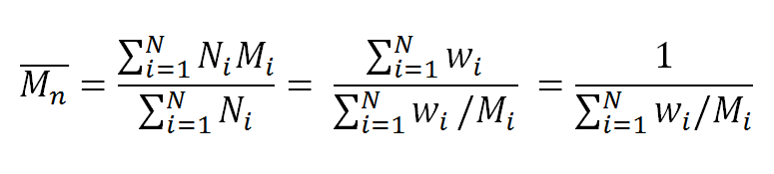
where N_{i} the number of molecules having a molecular weight M_{i}, and w_{i} is the weight fraction of all molecules having a molecular weight M_{i}.
Another way to express the average molecular weight is to calculate the weight average, which is the sum of all molecular weights multiplied by their weight fractions:
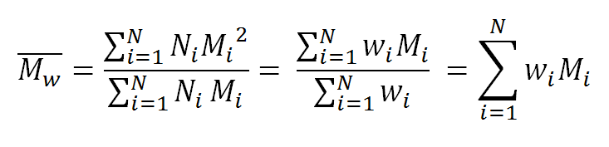
The two expressions for the average molecular weight are special cases of the general expression for weight averages:
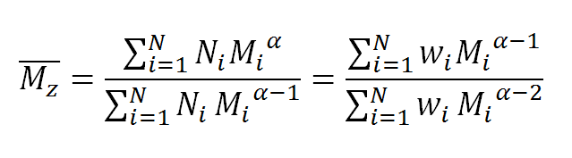
The parameter α is the so-called weighting factor, which defines the particular average. The higher averages, which are often called z-averages, are more sensitive to high molecular weight portions and are more difficult to measure accurately. They are related to methods that measure the motion of polymer molecules, such as diffusion or sedimentation methods.
It can be shown that the weight average molecular weight is a good measure for the expected statistical size of the polymer, whereas the number average molecular weight is a measure for the chain length. The two averages can lead to very different molecular weight averages. The weight average is particularly sensitive to the presence of higher molecular weight molecules whereas the number average is very sensitive to the presence of lower molecular weight molecules. For example, if equal parts by weight of molecules with a molecular weight of 10,000 and 100,000 g/mol are mixed then the weight average molecular weight is 55,000 g/mol whereas the number average is only 18182 g/mol. If, on the other hand, equal numbers of both molecules are mixed then the weight average is 91818 g/mol and the number average 55,000 g/mol. For all polydisperse synthetic polymers with bell-shaped distribution of molecular weight we find
M_{n} < M_{w} < M_{z} < M_{z+1}
The ratio M_{w} / M_{n} is called the polydispersity or heterogeneity index. It is a measure for the broadness of a molecular weight distribution of a polymer, that is, the larger the polydispersity index, the broader the molecular weight distribution.
The average molecular weight is related to the viscosity of the polymer under specific conditions. In the case of solution viscosity, the weight dependence of the viscosity can be described by the well-known empirical Mark-Houwink (1940) relation:
[η] = K_{η} M_{η}^{α}
where [η] is the intrinsic viscosity, and α, K_{η} are the Mark-Houwink parameters. These two quantities have been measured for many polymers.
Measurements of the viscosity yields the viscosity average molar weight:
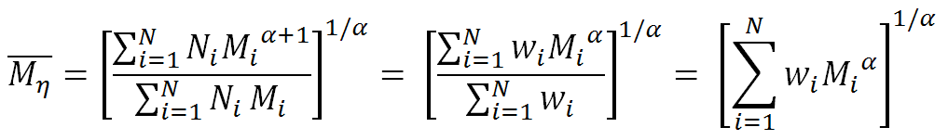
The viscosity average is usually larger than the mass average but smaller than the number average, M_{n} < M_{η} < M_{w}. Two very common techniques for measuring the molecular mass of polymers are high-pressure liquid chromatography (HPLC), also known as size exclusion chromatography (SEC), and gel permeation chromatography (GPC). These techniques are based on forcing a polymer solution through a matrix of cross-linked polymer particles at high pressure of up to several hundred bars.

